Modelling drying patterns

Pattern

Actual
1 μm diameter particles separated by 1.7 μm in x and 1.07 μm in y.
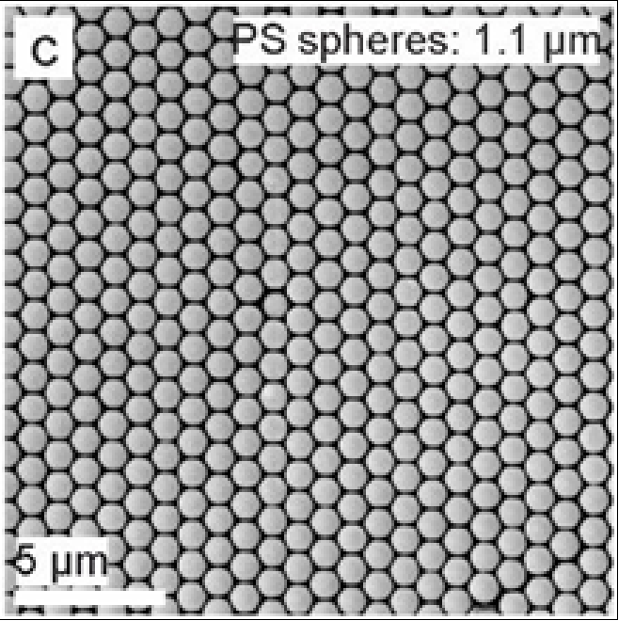

Modelled
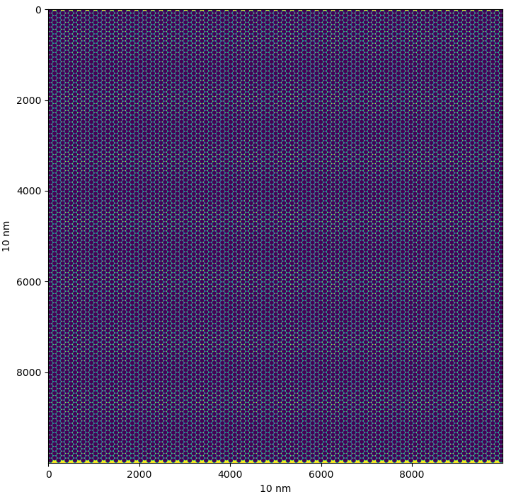
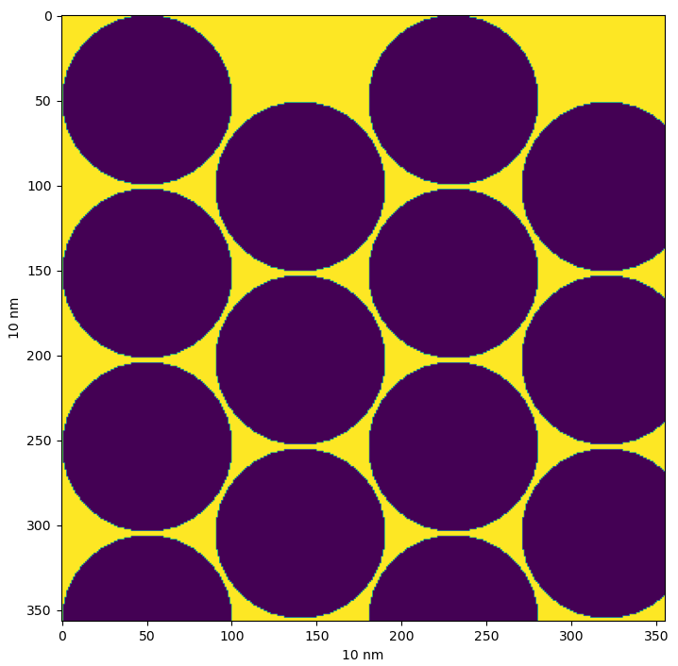

Autocorrelation
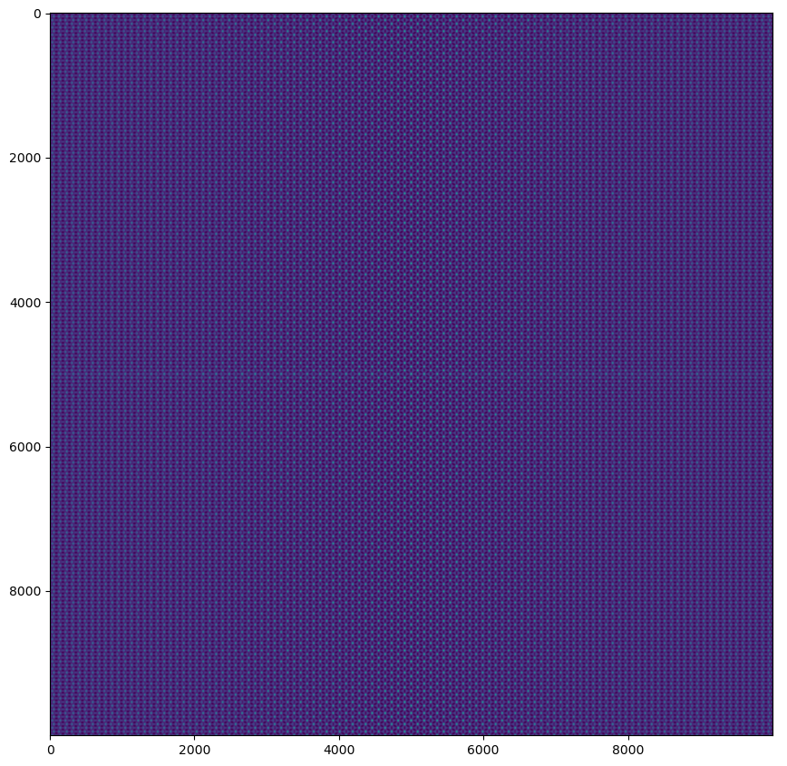

Zoom in middle
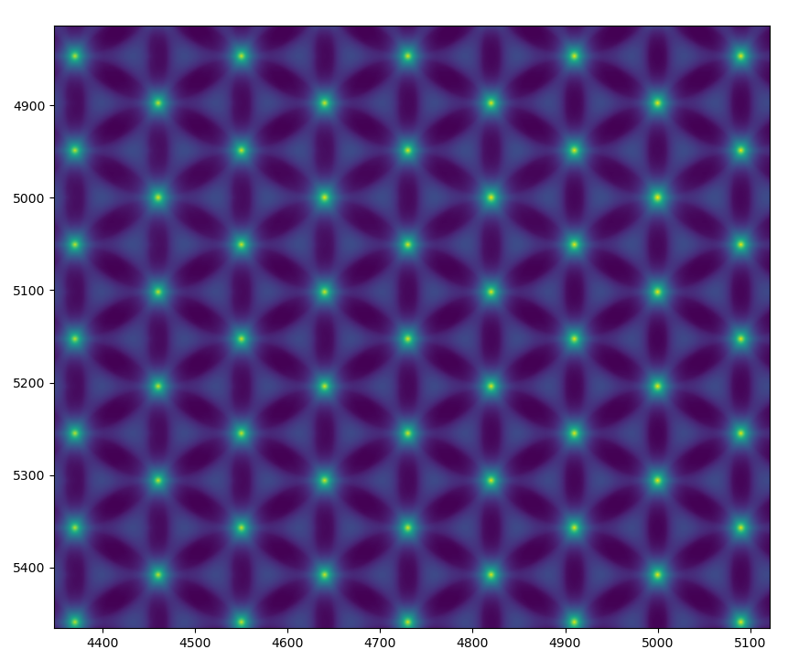

Zoom in edge
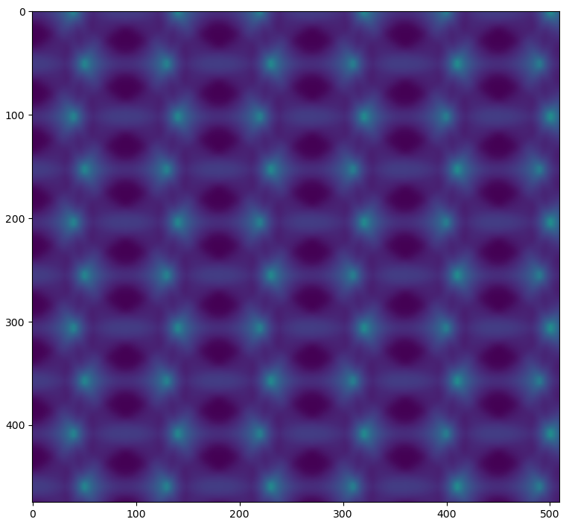

Projection in x and y
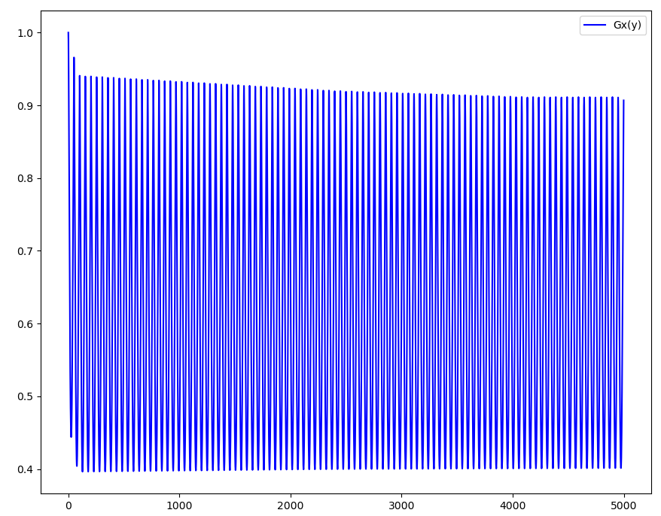
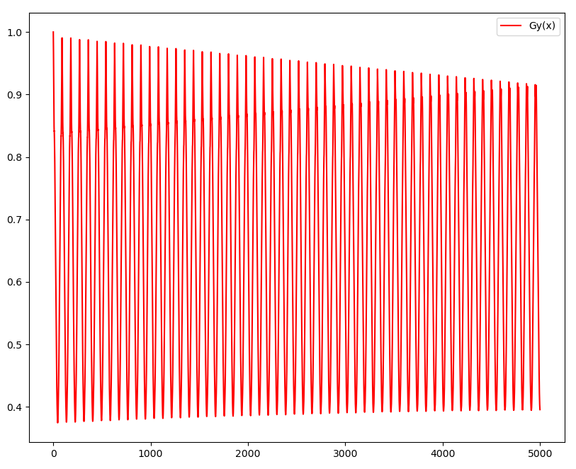
Fringe spacing (first 10 fringes)
Gx(y): 46
Gy(x): 81

Changing separation

Decreased separation
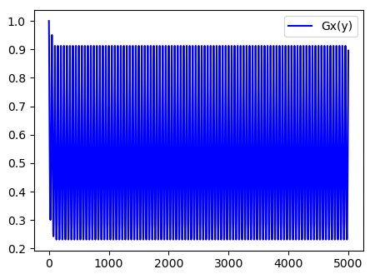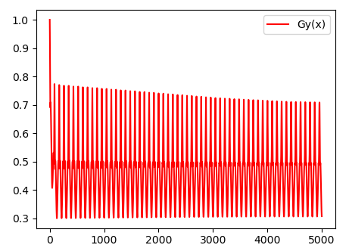
Fringe spacing (first 10 fringes)
Gx(y): 45
Gy(x): 78.3

Increase only y_separation
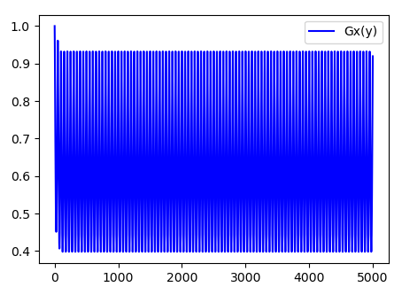
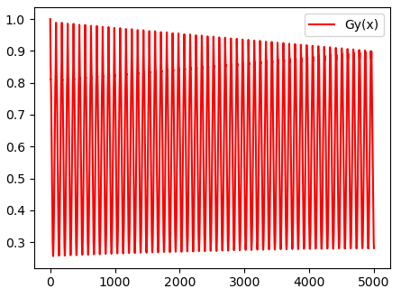
Fringe spacing (first 10 fringes)
Gx(y): 45
Gy(x): 81

Put y back and increase x
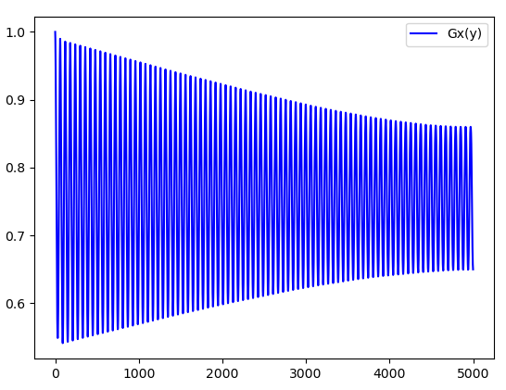

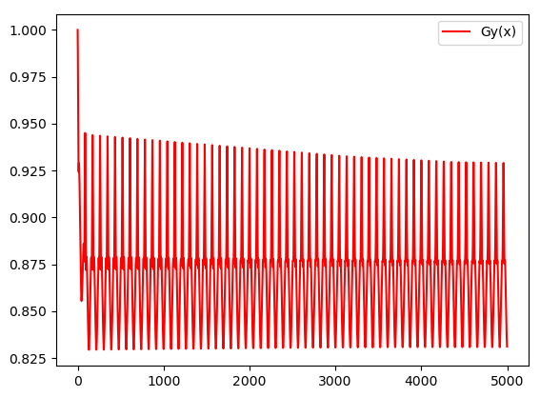
Fringe spacing (first 10 fringes)
Gx(y): 53.9
Gy(x): 78.1

Large x
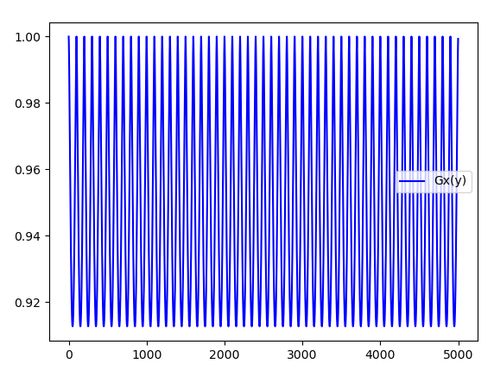
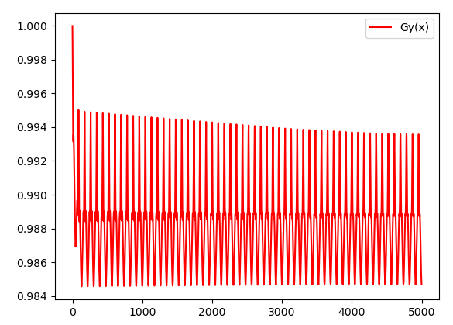
Fringe spacing (first 10 fringes)
Gx(y): 90
Gy(x): 78.1

